No exceptions! You must show all work and/or explain your answers to receive full credit.
( 10 points- 2 point per question)
Please Note : It is recommended that you print and write out your answers. Scan/take a photo and upload to the drop-box in Unit 4, Lesson 8 Slide 3. (You may use extra paper as needed – make sure it is uploaded as well.)

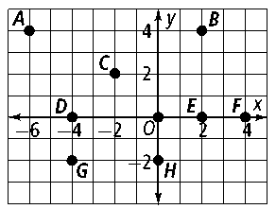
Lesson 9-1. Use the graph to answer the question.

- What rule describes the translation D → H?

(x, y) → ( x + _________, y + _________ )
- What rule describes the translation C→ G?

(x, y) → ( x + _________, y + _________ )

Lesson 9-2.

3. What are the two shortest words in the English language that you can write with capital letters so that each word looks like its own reflection across a line?

________________ and _______________

Lesson 9-3. Draw the image of the figure for the given rotation about P. Label the vertices of the image.

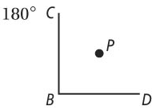
4.

Lesson 9-4. State the kind of symmetry the figure has.

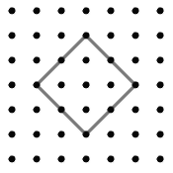
5.

______________________________________________

Lesson 9-5 and 9-6. A dilation has center (0, 0). Find the image of the point for the given scale factor.

6. 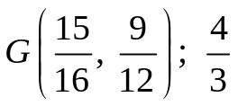 ___________________________

7. A triangle has an area of 40 cm². Following a dilation, the new area of the triangle is 360 cm². What is the scale factor of the dilation?

___________________________

P(2, 3) → P′ by a glide reflection with the given translation and line of reflection.
What are the coordinates of P′? (Hint: it may help to graph the transformations.)
8. (x, y) → (x + 3, y − 2); y = 0 9. (x, y) → (x − 4, y + 2); x = 0

Lesson 9-7.

10. Use a square and an equilateral triangle to make a tessellation. The square and equilateral triangle should have congruent sides.

